# **What are Different Types of Processors : Applications and Characteristics**

Processors are invented by Marcian Hoff (28th October 1937 in New York). Some of the processor manufacturer companies are [Intel](https://www.elprocus.com/know-about-architecture-of-the-intel-8080-microprocessor/), AMD, Qualcomm, Motorola, Samsung, IBM, etc. The processors are small size chips made by silicon that are placed inside the devices to perform the task or operation within seconds and its speed is measured in terms of megahertz. The fetching, decoding, executing and write back the instructions are the four main primary functions of the processor. In mobile phones, laptops, computers, washing machines, etc processors are used. In this article, the different types of processors are discussed.

## **What is a Processor?**

**Definition:** The processor is a chip or a logical circuit that responds and processes the basic instructions to drive a particular computer. The main functions of the processor are fetching, decoding, executing, and write back the operations of an instruction. The processor is also called the brain of any system which incorporates computers, laptops, smartphones, embedded systems, etc. The ALU (Arithmetic Logic Unit) and CU (Control Unit) are the two parts of the processors. The Arithmetic Logic Unit performs all mathematical operations such as additions, multiplications, subtractions, divisions, etc and the control unit works like traffic police, it manages the command or the operation of the instructions. The processor communicates with the other components also they are input/output devices and memory/storage devices.

### **Types of Processors**

There are different types of processors in the embedded system which include the following.

### **General Purpose Processor**

There are five types of general-purpose processors they are, Microcontroller, Microprocessor, Embedded Processor, DSP and Media Processor.

#### **Microprocessor**

The general-purpose processors are represented by the microprocessor in embedded systems. There are different varieties of microprocessors available in the market from different companies. The microprocessor is also a general-purpose processor that consists of a control unit, ALU, a bunch of registers also called scratchpad registers, control registers and status registers.

There may be an on-chip memory and some interfaces for communicating with the external world like interrupt lines, other lines for the memory and ports for communicating with the external world. The ports often called the programmable ports that means, we can program these ports either to be acting as an input or as an output. The general-purpose processors are shown in the below table.

**Microcontroller**

The microcontroller is basically a computer that comes in various packages and sizes. The reading input and responding to output is the basic function of the microcontroller. Generally, it is known as General Purpose Input Output (GPIO). Some of the microcontrollers are Microchip Atmega328-AU, Microchip P1C16F877A-I/P, Microchip P1C16F1503-I/P, Microchip P1C16F671-I/SN, Microchip P1C18F45K22-I/P, etc.

#### **Embedded Processor**

An embedded processor is one type of processor which is designed to control mechanical functions and electrical functions. It consists of several blocks they are the processor, timer, an interrupt controller, program memory and data memory, power supply, reset and clock oscillator circuits, system application-specific circuits, ports and interfacing circuits.

### **Digital Signal Processor**

The digital signal processor is one type of processor used for measuring, filtering and/or compress digital or analog signals. The signal processing means analysis and manipulation of signal. This processing can be done via computer or [Application Specific Integrated Circuits (ASIC)](https://www.elprocus.com/application-specific-integrated-circuits/), Field Programmable Gate Array (FPGA) or Digital Signal Processor (DSP) to obtain the clear signal. The DSP processors are used in an oscilloscope, barcode scanners, mobile phones, printers, etc. These processors are fast and use for real-time applications. The typical DSP system is shown in the below figure.

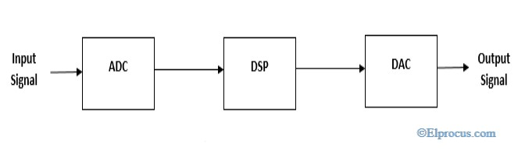*typical-system-for-digital-signal-processors*

#### **Applications of DSP**

The applications of the [digital signal processor](https://www.elprocus.com/digital-to-analog-converter-dac-applications/) are

* Speech processing
* Image processing
* Medical processing
* Biometric Processing
* Seismology
* Radar

### **Media Processor**

The image/video processor is the media processor that is designed or created to deal with the data in real-time. The voice user interface and professional audio are the applications of the audio processor. Some of the media processors are TN2302AP IP, IN2602 AP IP, DM3730, DM3725, DM37385, DM388, TMS320DM6467, TMS320DM6431, etc

### **Application-Specific System Processors (ASSPs)**

The application-specific system processor is a semiconductor [integrated circuit](https://www.elprocus.com/how-integrated-circuits-work-physically/) product used to implements a specific function. The performance, characteristics and die size of the application-specific system processor is the same as the ASIC. The ASSP’s are used in various types of industries to perform video encoding or decoding and audio encoding or decoding. In place of embedded software, the application-specific system processor is used to run the application and it provides the solution faster. Example: IIM7100, W3100A.

### **Application-Specific Instruction Set Processors (ASIPs)**

The application-specific instruction-set processors are designed for specific applications. These processors have low power consumption, high computational speed, and good flexibility. Due to programmability, the data path utilization is high in ASIPs, and the performance of this instruction set processor is good.

### **ASIC Processors**

The application-specific integrated circuits are built for specific applications. These chips are small in size and consume low power. The design cost of ASIC is high and this is the main disadvantage. The application-specific integrated circuit chips are used in satellites, modems, computers, etc. Some of the top ASICs manufacturer companies are Ams AG. Listed Company, Bitfury. Private Company, XMOS [Semiconductor](https://www.elprocus.com/semiconductor-devices-types-and-applications/) Private Company, Analogix Semiconductor Private Company, EDAptive Computing Private Company, Lumen Radio Private Company, Integrated Device Technology, Hookit. Private Company, etc.

### **MultiProcessor**

The multiprocessor is a computer with more than one CPU, each shares main memory, a computer bus, and peripherals to simultaneously process the programs and these systems are also known as tightly coupled systems. The advantages of multiprocessors are increased throughput, increased reliability and economy of scale. These processors are used when very high speed is required to process a large volume of data. The symmetric multiprocessor is shown in the below figure.

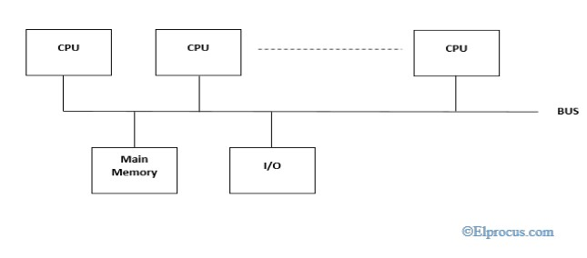*symmetric-multiprocessors*

### **Characteristics of Multiprocessors**

The Characteristics of Multiprocessor are

* The multiprocessors consist of more than two processors or two processors which are similar
* Memory and input/output facilities shared by the processors
* The access time of the memory is the same for each processor because the processors are connected by bus
* Access to the input/output devices are shared by the processors
* The same function performed by all the processor.

**Reduced Set Instruction Set Architecture (RISC) –**

The main idea behind is to make hardware simpler by using an instruction set composed of a few basic steps for loading, evaluating and storing operations just like a load command will load data, store command will store the data.

It is known as Reduced Instruction Set Computer. It is a type of microprocessor that has a limited number of instructions. They can execute their instructions very fast because instructions are very small and simple.

RISC chips require fewer transistors which make them cheaper to design and produce. In RISC, the instruction set contains simple and basic instructions from which more complex instruction can be produced. Most instructions complete in one cycle, which allows the processor to handle many instructions at same time.

In this instructions are register based and data transfer takes place from register to register.

**Complex Instruction Set Architecture (CISC) –**

CISC Processor

* It is known as Complex Instruction Set Computer.
* It was first developed by Intel.
* It contains large number of complex instructions.
* In this instructions are not register based.
* Instructions cannot be completed in one machine cycle.
* Data transfer is from memory to memory.
* Micro programmed control unit is found in CISC.
* Also they have variable instruction formats.

The main idea is that a single instruction will do all loading, evaluating and storing operations just like a multiplication command will do stuff like loading data, evaluating and storing it, hence it’s complex.

Both approaches try to increase the CPU performance

* **RISC:** Reduce the cycles per instruction at the cost of the number of instructions per program.
* **CISC:** The CISC approach attempts to minimize the number of instructions per program but at the cost of increase in number of cycles per instruction.

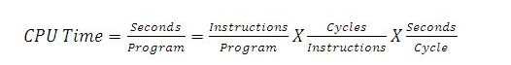

Earlier when programming was done using assembly language, a need was felt to make instruction do more task because programming in assembly was tedious and error prone due to which CISC architecture evolved but with uprise of high level language dependency on assembly reduced RISC architecture prevailed.

**Characteristic of RISC –**

1. Simpler instruction, hence simple instruction decoding.
2. Instruction come under size of one word.
3. Instruction take single clock cycle to get executed.
4. More number of general purpose register.
5. Simple Addressing Modes.
6. Less Data types.
7. Pipeling can be achieved.

**Characteristic of CISC –**

1. Complex instruction, hence complex instruction decoding.
2. Instruction are larger than one word size.
3. Instruction may take more than single clock cycle to get executed.
4. Less number of general purpose register as operation get performed in memory itself.
5. Complex Addressing Modes.
6. More Data types.

**Example –** Suppose we have to add two 8-bit number:

* **CISC approach:** There will be a single command or instruction for this like ADD which will perform the task.
* **RISC approach:** Here programmer will write first load command to load data in registers then it will use suitable operator and then it will store result in desired location.

So, add operation is divided into parts i.e. load, operate, store due to which RISC programs are longer and require more memory to get stored but require less transistors due to less complex command.

Difference Between CISC and RISC

|  |  |  |
| --- | --- | --- |
| **Architectural Characterstics** | **Complex Instruction Set Computer(CISC)** | **Reduced Instruction Set Computer(RISC)** |
| Instruction size and format | Large set of instructions with variable formats (16-64 bits per instruction). | Small set of instructions with fixed format (32 bit). |
| Data transfer | Memory to memory. | Register to register. |
| CPU control | Most micro coded using control memory (ROM) but modern CISC use hardwired control. | Mostly hardwired without control memory. |
| Instruction type | Not register based instructions. | Register based instructions. |
| Memory access | More memory access. | Less memory access. |
| Clocks | Includes multi-clocks. | Includes single clock. |
| Instruction nature | Instructions are complex. | Instructions are reduced and simple. |